Pictures & Descriptions within each decade:

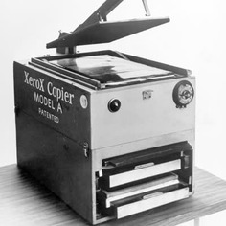
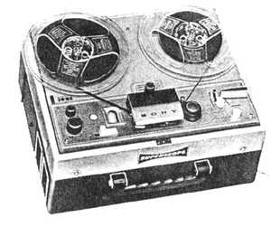
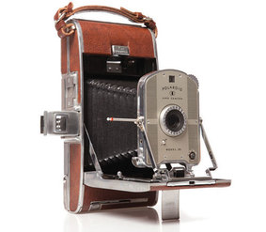
1930’s pictures and description:

For the 1930’s I chose the Polaroid camera, tape recorder, and the first photocopier as my inventions. All of these have associations with electronic devices. I chose the first Polaroid camera because I think it is so cool that you can have a camera and an instant photo! I chose the tape recorder because then you can listen to your favorite tapes at home. The photocopier is also very useful in today’s society. When we need to print a document out, the photocopier is what helps us achieve this task. All three of these things make society that much better. Even though, today the Polaroid camera is very rarely used and not a lot of people own a tape recorder; these things were very important to some people of our history. Out of all three, the photocopier is used still to this day, and we wouldn’t be able to print anything without it. Many of these inventions mentioned in the next decades are things we still use every day.

1940’s pictures and description:
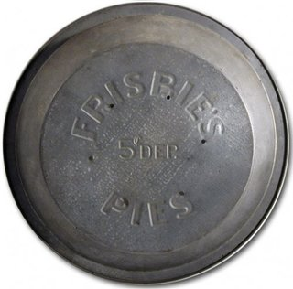
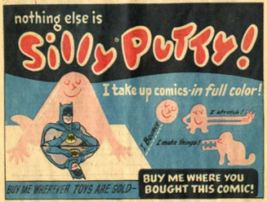
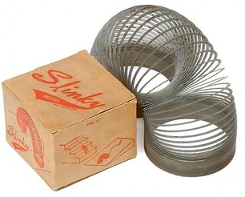

For the 1940’s I chose the Slinky, Silly Putty, and a Frisbee disk. All three of these inventions are just fun inventions used for entertainment. These things are not necessary to the world, but then again what is? The slinky is a fun toy to use when you are just bored and have nothing to do. Silly Putty is also fun to use with your siblings. (Just don’t stick it in your sister’s hair; from past experiences, very painful) The Frisbee disk is so much fun to play with at the beach or in the pool. Many of the inventions in these decades are things we use every day, but some inventions are just for play. Clearly, the people who created these things were looking to have something amusing to use. Without the Frisbee disk, what would we play with at the beach? What entertainment would we have? I have not seen or played with Silly Putty in such a long time, but I hope they still sell it in stores! Also, I cannot count how many times we have bought a slinky (and have broken it quite a few times.) These inventions are for one purpose and one purpose only, to enjoy yourself and have fun!

1950’s pictures and description:
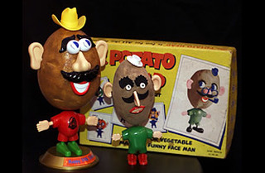
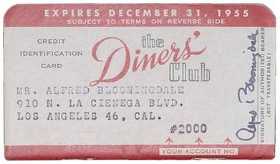

For the 1950’s I chose a Credit Card, Mr. Potato Head and a Barbie Doll. I chose these things because this was another decade of fun! The credit card just came out; you can buy whatever you want! The Mr. Potato Head looks quite different than the ones today, definitely more shaped like a potato. My personal favorite, out of all the decades… The Barbie Doll! I used to play with Barbie dolls ALL the time; every Saturday morning I would wake up and go in our play room and play with my Barbie’s. I had SO many, and I never wanted to give them away. I love the inventions that are for fun and entertainment. The world is such a serious place, and these inventors made time for enjoyable fun! This decade; the 1950’s has always been my favorite. I love the fashion, the families, and the way life was back then. If I could go back in time and live in any decade, I would choose the 1950’s for sure. I love everything about it! The style was so classy, so feminine and girly and those are three words to describe me! I love the inventions of the 1950’s!

1960’s pictures and description:
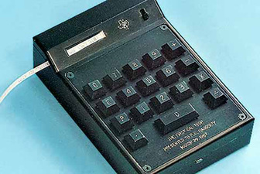
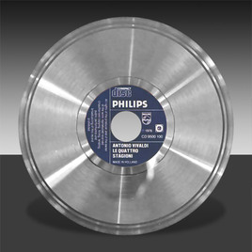
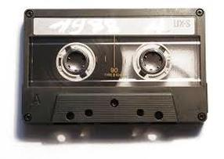

For the 1960’s I chose the audio cassette, the compact disk (CD) and the first hand held calculator. These three things are all in the electronic department. A ton of people back in the day used the audio cassette, I remember we used to have one, and in our car. People today still use the CD, we use it for many things; games, music, etc. The first hand held calculator was also a part of these inventions. This is also something that we still use today; and will probably continue to use. If you need help multiplying or adding numbers, just click a few buttons, and the answer is right at your hands. These inventions are definitely still used in today’s society, minus the audio cassette. Some people though, collect audio cassettes and players and use it for music!

1970’s pictures and description:
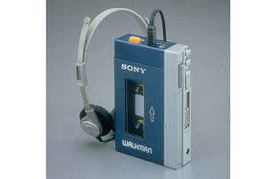
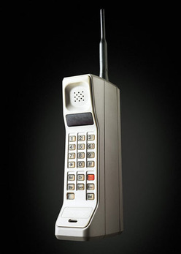
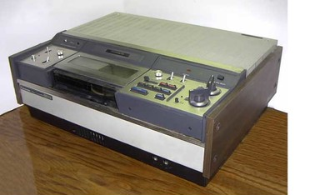

For the 1970’s I chose the first video cassette (VCR), the cell phone, and the Walkman. These inventions all have to do with electronics. The VCR is used for entertainment, and so is the Walkman. The cell phone is an invention out of all three that we still use to this day. These inventions were so much fun to research. I think of the top 5 inventions, the cell phone would definitely be one of them. What would we do today if we didn’t have cell phones? How about my childhood, I lived on VCRs so I could watch my VHS’s. I don’t know what we would’ve done if we didn’t have video players to watch our videos. It really does not seem like that long ago that we had a VCR player. Now, we have DVD’s and there are not a lot of people today who have a VCR player. These three inventions were very important to people of this decade. The 1960’s was a big time of change, and it actually affected the 70’s as well. Inventions are very important, and the cell phone made the top of the list. Even though two of these inventions are for entertainment, they are all very important and fun to use.

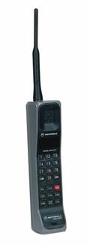
1980’s pictures and description:
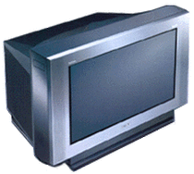
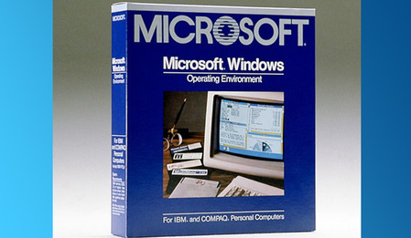

For the 1980’s I also chose three inventions that have to do with technology and electronics. The Windows Program is very important; without it I would not be able to type this paper! It is incredibly useful to have and it has so many options to choose from, and they keep updating it every year. The digital cell phone was also created at this time; which is also extremely important to today’s society. Our phones definitely do not look like that anymore, but they are more improved and better quality. The TV also was invented at this time, and this was yet another great invention. When you are bored and have nothing to do, a lot of people watch TV. You can also watch movies on the TV and your favorite shows. Imagine sitting down on the night of your favorite show, and not being able to watch it. This is what it would be like if we had no TV. This was another one of the top inventions of our time. These inventions are so very important to today’s society. The world would be a much different place without the TV, cell phones, or the Window’s Program. Thanks to the inventors; we can use these things daily!

1990’s pictures and description:
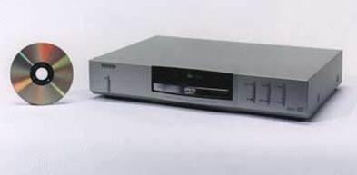
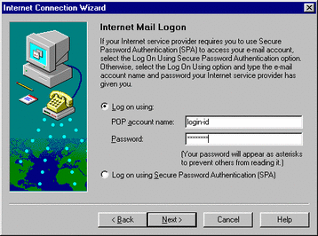
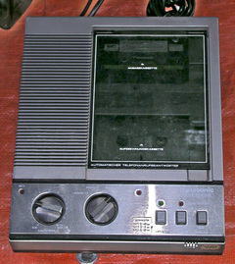

And last, but certainly not least; the 1990’s. This was a time of great change for the world. New technology and new improvements of electronics grew and prospered at this time. I chose the first digital answering machine, the Internet, and the DVD. Besides the answering machine, the Internet and the DVD were huge inventions and are widely used today. The answering machine is great, because then people can leave you messages when you are not home to receive them. The Internet, on the other hand is a huge step for mankind! No more having to look up information needed in a book at the library. You have all the answers you need right at the tip of your fingers. Having the Internet has changed so many people’s lives. The DVD was also invented during the 1990’s. This was also another big step for the movie industry. Say goodbye to dusty old VHS’s (so sad) and say hello to Blu-Ray and new DVDs! These inventions were so necessary to us; and we still use them today. There are so many inventions that were made over the past 80 decades. The ones I mentioned in these descriptions are either for entertainment or very critical to today’s society. Either way, these inventions are incredible!

